Lecture 6
WATER, ACIDS, BASES AND BUFFER
Introduction
Water is the most abundant matter on earth and also in all living creatures. Typically, organisms are constituted of 70 to 90 % water. Water must be present before any metabolic activity can take place in the cell. It is referred to as a weak electrolyte because it can undergo partial dissociation to two ions made up of a proton (H⁺) and hydroxyl ion (OH⁻). Acids and Bases are defined with respect to their ability to gain or loss protons. Buffer is a solution that resists change in the pH of a solution when proton or hydroxyl ions are suddenly added. Concentration of these ions determines the degree of acidity or alkalinity of solutions, including body fluids.

The Properties of Water
Water is one of the most important substances on earth. It is the basic molecule of life. In Biochemistry water is the predominant chemical component of living organisms. The human body is about 70% water. It plays a role in transportation of materials to and from the cells. It is the aqueous solution for biochemical reactions. It acts as solvent for biochemical reactions in the body and help in maintaining the temperature of the body.
Water exists in three different forms: vapour/steam, solid and liquid.
Above 100 ºC as vapour, below 0 ºC as solid, between 0 ºC and 100 ºC as liquid.
Some important properties of water are:
Polarity - In a water molecule two hydrogen atoms form single polar covalent bonds with an oxygen atom. This gives water more structure than other liquids. Because oxygen is more electronegative, the region around oxygen has a partial negative charge. The region near the two hydrogen atoms has a partial positive charge. Thus, water molecule is a polar molecule with opposite ends of the molecule with opposite charges.
Universal solvent – water is regarded as universal solvent, meaning many compounds can dissolve in it. Because of its high polar nature, water is an excellent solvent for polar and ionic (hydrophilic) substances such as salt and non-ionic but polar substances such as sugars. Water is poor solvent for non-polar (hydrophobic) substances.
Hydrogen bond – hydrogen bond hold water molecule together. The region around oxygen has a partial negative charge while the region near the two hydrogen atoms has a partial positive charge. The slightly negative regions of one molecule are attracted to the slightly positive regions of nearby molecules, forming a hydrogen bond. Each water molecule can form hydrogen bonds with up to four neighbors. Each water molecule can form a maximum of 4 hydrogen bonds. The hydrogen bonds joining water molecules are weak, about 1/20th as strong as covalent bonds. They form, break, and reform with great frequency.
High specific heat – Specific heat of a substance is the amount of heat required to raise/change its temperature by 1 ºC. The amount of heat energy (calories) required to raise the temperature of one gram of water from 15 ºC to 16 ºC is known as specific heat of water. Water with its high specific heat helps to maintain the constant temperature of living organisms in the varying environmental temperature.
High heat of vaporization – Heat of vaporization is defined as the no of calories required to change one gram of liquid into vapour.
Vaporization is commonly called evaporation. When water evaporates from the surface of the skin, it absorbs a great deal of heat from the body thus evaporation has a cooling effect. Thus high heat of vaporization helps to regulate body temperature and prevent organisms from overheating.

Biological Importance of Water
- A molecule with electrical charge distributed unequally about its structure is referred to as a dipole. H₃O = H⁺ + OH-.
In simpler terms, it means one end of the molecule has a slight positive charge while the other end has a slight negative charge, creating a "positive" and "negative" side within the molecule.
H₃O = H⁺ + OH-: This equation represents the dissociation of a water molecule (H₂O) into hydronium (H3O+) and hydroxide (OH-) ions. In this case, the water molecule loses a hydrogen ion (H⁺) to become a positively charged hydronium ion (H3O+), leaving behind a negatively charged hydroxide ion (OH-). This dissociation occurs in aqueous solutions, making water an example of a polar molecule and a dipole because of the unequal distribution of charge between its hydrogen and oxygen atoms.
- The strong dipole and high dielectric constant of water enables it to dissolve large quantities of charged compounds.
- Presence of hydrogen bond also enables water to dissolve many organic molecules that contain functional groups.
- Water provide environment for macromolecules to achieve stable structure in solution.

Acid, Base and Buffer
Acid is a compound that dissociates in aqueous solution to produce proton (H+) and a conjugate base (A-).
HA = H + A
Acid may dissociate partially (weak acid) or completely (strong acid) in solution. In solution, weak acid establishes equilibrium between the proton and its conjugate base.
The equilibrium constant is called the acid dissociation constant (Ka) where K is the constant and a is the acid.
Ka = [H+] [A-]
[HA]
Base is a compound that accepts proton in aqueous environment, for example ammonia reacts with a proton to produce an ammonium ion.

Calculation of pH, pOH and pKa

The pH of a solution is simply defined as the negative logarithm of hydrogen ions concentration,
pH = - log [H+] and
pOH = - log [OH-].

Most living cells have a very narrow range of tolerance for pH, i.e. [H⁺]. The [H⁺] concentration will be important (either explicitly or implicitly) for many other topics in biology. [H⁺] is controlled in all biological organisms, and in virtually all biochemical experiments. Each pH unit represents a factor of 10 differences in [H⁺].
The pH of some body fluids must occupy a very narrow range. For example, a healthy individual has a blood pH in the range of 7.35–7.45. Maintaining this pH is crucial to the life of the individual. The pH of other fluids can be more variable. Urine has a pH anywhere from 4.6–8.0, depending on an individual’s recent diet and exercise.
The pH scale is a way of expressing the strength of acids and bases. Instead of using very small numbers, the negative power of 10 on the molarity of the H+ (or OH⁻) ion is used. On the pH scale, values below 7 are acidic, value of 7 is neutral, while values above 7 are basic (alkaline).
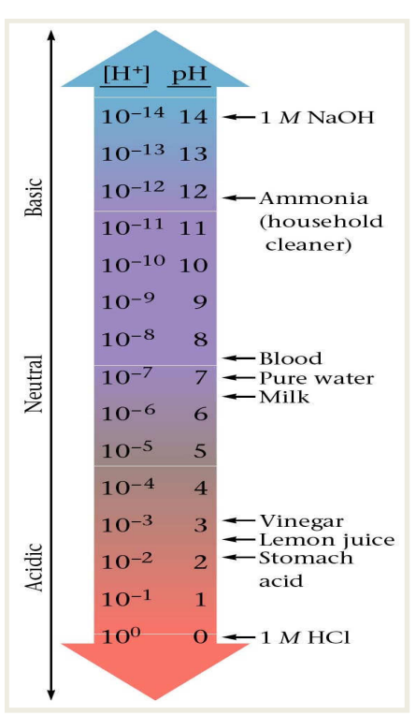Figure 21: The pH scale.
As with the hydrogen ion concentration, the concentration of the hydroxide ion can also be expressed logarithmically as pOH. The pOH of a solution can though be defined as the negative logarithm of the hydroxide ion concentration.
pOH = -log[OH⁻]

The pOH scale is similar to the pH scale in that a pOH of 7 is indicative of a neutral solution. A basic solution has a pOH of less than 7, while an acidic solution has a pOH value greater than 7. The pOH can be used to determine the hydroxide ion concentration from a solution with a known
pH. Thus, pH and pOH are related as follows:
pH + pOH = 14
Example 1: If the H+ concentration of a solution is 4.2 x 10-3 calculate the pH of the solution.
Solution:
pH = - log [H+] , log[4.2 x 10-3] = log 4.2 + log 10-3 = 0.62 -3 = -
2.38. Substitute for log [H+] in the equation.
pH = -(-2.38), the two negative values cancelled out, pH = 2.38
Example 2: Calculate the [H+], [OH-] and pH of 0.01M ethanoic acid, given that (Ka = 1.76 x 10-5).
Solution:
Note that ethanoic acid is a weak acid, it dissociates partially in solution, therefore HA = H+ + A- , if the conjugates are represented by x, then HA = 0.1- x ≈ 0.1(value of x is negligible)
Ka = [H+] [A-]
[HA]
Ka = 1.76 x 10-5 = x2/0.1
x2 = 1.76 x 10-6 , x is equal to the square root of 1.76 x 10-6
this is equal to 1.33 x 10-3, therefore,
[H+] = 1.33 x 10-3
pH = -log 1.33 x 10-3 = 0.12-3, if you take away 3 from 0.12, this will
give you a negative value ( -2.88).
pH = 2.88 .
To calculate the pOH, the dissociation of pure water will be considered.
H3O = H+ + OH-,
[H+] + [OH-] = 1.0 x10-14,
[OH-] = 1.0 x 10-14/ [H+]
= 1.0 x 10-14/1.33 x 10-3,
[OH-] =7.52 x 10-12.
But pOH = -log 7.52 x 10-12
This is equal to 0.88 – 12,
pOH = 11.12

Example 3
Given a solution with a hydrogen ion concentration [H⁺] of 1 x 10⁻⁴ M, calculate the pH, pOH, and pKa if the acid dissociation constant (Ka) is 1 x 10⁻⁵.

- pH Calculation: pH = -log[H⁺] = -log(1 x 10⁻⁴) = 4.
- pOH Calculation: pOH = 14 - pH = 14 - 4 = 10.
- pKa Calculation: pKa = -log(Ka) = -log(1 x 10⁻⁵) = 5.

Buffers
A buffer is a solution that can resist changes in pH upon addition of acid or basic components. Buffers are able to neutralize small amount of added acid or base to maintain the pH of the solution relatively stable.
Most buffers are solutions composed of approximately equal amounts of a weak acid and salt of its conjugate base. Buffers help organisms maintain the pH of body fluids within the narrow range necessary for life. They work by accepting H⁺ from solutions when they are in excess and by donating H⁺ when they have been depleted.
Body fluids such as blood, cerebrospinal fluid, saliva etc. have constant pH under normal physiological conditions. This is possible due to the presence of buffer in these fluids. Hydrogen and hydroxyl ions are constantly added to the body fluids as products of metabolism.

Characteristics of a buffer
i. It has a definite pH value
ii. Its pH value doesn’t change even with the addition of a small amount of strong acid or base.
iii. Its pH value doesn’t change on keeping for a long time.
iv. Its pH value doesn’t change on dilution.

Table: Approximate pH values of some body fluids.
Body fluid | Physiological pH
Saliva | 5.8 - 7.1
Pancreatic juice | 7.5 - 8.8
Blood | 7.4
Gastric juice | 1.6 - 1.8
Urine | 4.6 - 8.0

Physiological Buffers
Physiological buffers are chemical substances used by the body to prevent large changes in the pH of the body fluids.
The four types of physiological buffers are the bicarbonate, phosphate, hemoglobin and protein buffer systems. The bicarbonate buffer is the major regulator of blood pH. The phosphate buffer regulates the cytosolic pH. [CO₂] and [HCO₃] are much higher than [PO₄] in blood; the reverse is true in the cytosol, [PO₄] is much greater than [HCO₃].

The bicarbonate CO₂ system works as follows: If hydrogen ions enter the blood, then they combine with base (HCO₃) to form carbonic respiration to exhale more CO₂. If a large amount of an acid is added to the blood, the quick compensation is an excretion of CO₂ with a reduction in the plasma bicarbonate: the slower compensation is that the acid is excreted by the kidneys which replace bicarbonate in the blood.
Removal of hydrogen ions from blood—as for example, following HCl secretion into the stomach—is compensated for by retaining CO₂ and forming more base (in the short term). In both cases, the respiratory system makes rapid buffering possible; the renal system supplies the long-term buffering.

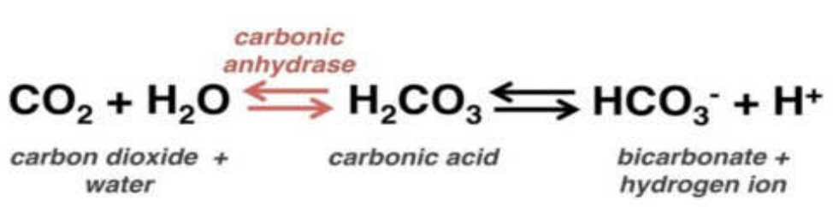
Equation: conversion of carbon dioxide to bicarbonate.

Blood Bicarbonate and Metabolic Acidosis
The bicarbonate blood buffer in a normal adult maintains the blood pH at around 7.40. If the blood pH drops below 7.35, the condition is referred to as an acidosis. A prolonged blood pH below 7.0 can lead to death. Clinically for an acidosis, the acid-base parameters (pH, [HCO₃-], [CO₂]) of the patient’s blood should be monitored. The normal values for these are pH = 7.40; [HCO₃-] = 24 mM; [CO₂] = 1.2 mM.

Metabolic acidosis is an electrolyte disorder characterized by disturbance in the body’s acid-base balance mechanisms. The three major root causes of metabolic acidosis are:
- Increased acid production
- Loss of bicarbonate and,
- Reduced ability of the kidneys to excrete excess acids.
Metabolic acidosis is characterized by low concentration of bicarbonate, which can happen with increased generation of acids such as ketoacids or lactic acids, excess loss of bicarbonate by the kidneys or gastrointestinal tract.
Henderson-Hasselbalch Equation
The Henderson-Hasselbalch equation is an equation that shows the relationship between the pH of a solution, the pKa and the ratio of the conjugate base and conjugate acid. The equation is useful for estimating the pH of a buffer solution and finding the equilibrium pH in an acid-base reaction. The equation can be used to determine the pH of different solutions in different chemical equations as well as in the biological systems like enzymes and other proteins.
The Henderson-Hasselbalch equation is given as follows:
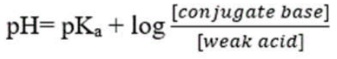

Example: What would be the pH of a solution containing 0.1 M CH₃COO⁻ and 0.9 M CH₃COOH? (pKa = 4.76)
Solution: pH = pKa + Log [A-] /[HA]
CH₃C00H CH₃C00⁻ + H⁺
pH = 4.76 + log(0.1/0.9)
pH = 4.76 + log 0.111
pH = 4.76 + (-0.95)
pH = 3.81

